Breast Cancer Prediction

Saurabh Biswas & Gourav Verma

DSC-630 Predictive Analytics

Bellevue University, NE

Fall-2020

**Executive Summary**

Early detection of disease has become a crucial problem due to rapid population growth in medical research in recent times. The uncontrollable division of one cell results in a visible mass named tumor. A tumor can be benign or malignant. By Johns Hopkins Pathology, benign tumors are non-malignant/non-cancerous tumors and malignant tumors are cancerous growths. Cancer is another word for a malignant tumor. Most benign tumors respond well to treatment. But malignant tumors are often resistant to treatment, may spread to other parts of the body and they sometimes recur after they were removed. Common biopsies for breast cancer diagnosis include fine-needle aspiration (FNA), core needle biopsy, and MRI-guided biopsy. A FNA is an effective tool in evaluating and diagnosing suspect lumps or masses. In this analysis, we have used ten features of tumor cell nuclei extracted from the digital image processing of an FNA of a breast mass to predict breast cancer.

Machine Learning (ML) is one of the core branches of Artificial Intelligence. It’s a system that takes in data, finds patterns, trains itself using the data, and outputs an outcome. We have developed a classification model that will identify breast cancer using the FNA diagnosis label with 95.8% accuracy. This model will be great for predicting cancer in advance, because classification algorithms make boundaries between data points classifying them as a certain group, depending on their characteristics matched against the model’s parameters.

At present, you perform clinical tests, at a clinic. Data is inputted into a pathological ML system. A few minutes later, you receive an email with a detailed report that has an accurate prediction about the development of your cancer. While you might not see AI doing the job of a pathologist today, in the future of cancer biopsy you can expect ML to replace your local pathologist in the coming decades, and it’s pretty exciting!

# Abstract

Breast cancer or breast carcinoma is uncontrolled growth of epithelial cells in the breast. The uncontrollable division of one cell results in visible mass named tumor. Tumor can be benign or malignant. By Johns Hopkins Pathology, benign tumors are non-malignant/non-cancerous tumor and malignant tumors are cancerous growths. A cancer is another word for a malignant tumor. Most benign tumors respond well to treatment. But, malignant tumors are often resistant to treatment, may spread to other parts of the body and they sometimes recur after they were removed. Under a study by University of Wisconsin, 569 patients (212 with cancer and 357 with benign masses) provided the data for diagnostic algorithm. Diagnostic features are computed from a digitized image of a fine needle aspirate (FNA) of a breast mass. They describe characteristics of the cell nuclei present in the image in the 3-dimensional space is that described in: [K. P. Bennett and O. L. Mangasarian: "Robust Linear Programming Discrimination of Two Linearly Inseparable Sets", Optimization Methods and Software 1, 1992, 23-34]. Breast cancer is the most common malignancy in women, with over 200,000 being diagnosed in the US every year. 40,000 women will die from it each year. The objective of this research is to provide a comparative study on the utilized potential classification tools (Linear regression, random forest) on the problem by a benchmark dataset which consist of numeric cellular shape features extracted from preprocessed Fine Needle Aspiration biopsy image of cell slides.

*Keywords:* FNA, Linear Regression, Random Forest, Cancer, Machine learning, prediction model.

Table of Contents

Abstract 3

Problem Statement 5

Data 5

Methodology 9

Results 10

Discussion 12

Acknowledgments 13

References 13

# Problem Statement

Breast Cancer is the 2nd most common cancer in women. But, on rare scenario can also happen to men. It is 2nd leading cause of deaths of women after lung cancer. A fine needle biopsy is an effective tool in evaluating and diagnosing suspect lumps or masses. With early diagnosis of breast cancer, patients can be isolated for early treatment for a better chance of survival. Common biopsies for breast cancer diagnosis includes fine-needle aspiration (FNA), core needle biopsy, and MRI-guided biopsy. In this analysis, we will be using ten features of tumour cell nuclei extracted from the digital image processing of an FNA of a breast mass to predict breast cancer. The data is collected from UCI Machine learning repository.

# Data

The benchmark dataset in this research will obtained from the UCI Irvine machine learning repository http://archive.ics.uci.edu/ml/index.html. This dataset was originally created by Dr. Wolberg, Street and Mangasarian all from University of Wisconsin. Data items in the dataset are composed of ID number, the diagnosis which will either be classified as malignant (M) or benign(B) and numeric shape features of extract cellular nuclei such as radius, texture, perimeter, area, smoothness, compactness, concavity, concave points, and symmetry and fractal dimension. Each of the dataset in the observation is composed of 30 variables and 10 of the featured variables are related to the aforementioned characteristics. As described in the website, following main features were computed for each cell nucleus and will be used as input for our analysis. All feature values are recoded with four significant digits.

1. radius (mean of distances from center to points on the perimeter)
2. Texture (standard deviation of gray-scale values)
3. Perimeter
4. Area
5. Smoothness (local variation in radius lengths)
6. Compactness (perimeter^2 / area - 1.0)
7. Concavity (severity of concave portions of the contour)
8. Concave points (number of concave portions of the contour)
9. Symmetry
10. Fractal dimension ("coastline approximation" - 1)

The mean, standard error and "worst" or largest (mean of the three largest values) of these features were computed for each image, resulting in 30 features. For instance, field 3 is Mean Radius, field 13 is Radius SE, and field 23 is Worst Radius. There are no missing values in the dataset. ‘diagnosis’ is the target variable. The total numbers of data samples with different labels are not balanced. In fact, the total number (357) of data samples labelled as B (benign) is almost doubled the total number (212) of data samples labelled as M (malignant).



For the purpose of running machine learning algorithm, the target variable values have translated from B (benign) to 0 and M (malignant) to 1. Target variable ‘0’ will be treated as no cancer and ‘1’ will be treated as breast cancer. We have dropped ‘Id’ column as it won’t provide any value in determining breast cancer outcome.

Snapshot of the correlation table:



Correlation Heatmap:

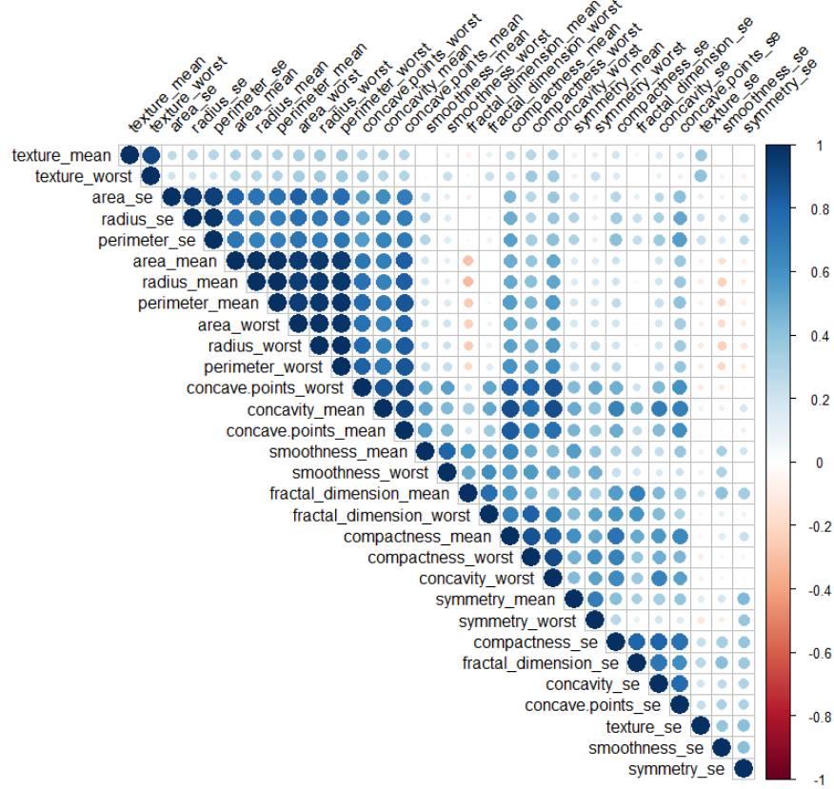

Based on the above heatmap and correlation table value - radius_mean, perimeter_mean & area_mean have higher correlation, radius_worst, perimeter_worst & area_worst have higher correlation (>0.98). So, we have kept perimeter_mean & perimeter_worst and dropped other correlated columns for further analysis.

We also can see that diagnosis variable has higher correlation value with perimeter_mean, concave points_mean, perimeter_worst, concave points_worst (>0.70). Before performing any data cleaning activity, we have divided our dataset into train and test dataset in 75/25 ratio.





Any outliers in perimeter_mean, concave points_mean, perimeter_worst, concave points_worst will have impact in final outcome of the model. So, it is important to identify the outliers and remove them from training dataset. perimeter_mean, concave points_mean, perimeter_worst contained outliers. So, we removed them from training dataset using z-score calculation (z-score > 3 can be considered as an outliers).

Boxplots to determine the outliers:



# Methodology

Our aim is to build a classification model that will identify breast cancer using diagnosis label. For this purpose, we are planning to use logistic regression classifier, Random Forest classifier. Logistic Regression classifier will establish the baseline training results and we will compare that with results from Random Forest.

Logistic regression (LR) is a statistical method similar to linear regression since LR finds an equation that predicts an outcome for a binary variable, Y, from one or more response variables, X. However, unlike linear regression the response variables can be categorical or continuous, as the model does not strictly require continuous data. To predict group membership, LR uses the log odds ratio rather than probabilities and an iterative maximum likelihood method rather than a least square to fit the final model. This means the researcher has more freedom when using LR and the method may be more appropriate for nonnormally distributed data or when the samples have unequal covariance matrices. Logistic regression assumes independence among variables, which is not always met in morphoscopic datasets. However, as is often the case, the applicability of the method (and how well it works, e.g., the classification error) often trumps statistical assumptions.

Random forest is a classifier that evolves from decision trees. It actually consists of many decision trees. To classify a new instance, each decision tree provides a classification for input data; random forest collects the classifications and chooses the most voted prediction as the result. The input of each tree is sampled data from the original dataset. In addition, a subset of features is randomly selected from the optional features to grow the tree at each node. Each tree is grown without pruning. Essentially, random forest enables a large number of weak or weakly-correlated classifiers to form a strong classifier. The Random Forests algorithm had a substantial impact on medical image computing over the last decade.

# Results

We used sklearn’s GridSearchCV to fine tune the parameters for above model and then compared the results. We have created Pipelines for Random Forest and Logistic Regression model with different parameters. Then we passed different values through these pipeline parameters to GridSearchCV for module tuning. We have used seeding for reproducibility.

Our parameter tuning results are as follows:

|  |  |  |
| --- | --- | --- |
| Model | Best Parameter | Accuracy |
| RF | rf__class_weight: balanced | 0.964 |
| rf__max_depth: 6 |
| rf__max_features: sqrt |
| rf__n_estimators: 100 |
| LR | logistic__C: 10.0 | 0.962 |
| select_best__k: all |

Random Forest classifier are not best suited for skewed class distribution. Our dataset is imbalanced dataset. But it is not heavily imbalanced (cancer: no-cancer as 1:2). So, we decided that we don’t need calibration.

Based on the accuracy we selected the best parameters for Random Forest and Logistic Regression classifier. Also based on the accuracy, we have selected Random Forest as our best model.

We have then tested both of these models using our test dataset and calculated accuracy and f1-score. f1-score is a harmonic mean of precision-recall. We have also produced confusion matrix for each test.

|  |  |  |
| --- | --- | --- |
|  | **Random Forest** | **Logistic Regression** |
| **Accuracy** | 0.958 | 0.93 |
| **F1-Score** | 0.944 | 0.907 |

Random Forest Confusion Matrix:

|  |  |
| --- | --- |
| TP: 86 | TN: 4 |
| FP: 2 | FN:51 |

Logistic Regression Confusion Matrix:

|  |  |
| --- | --- |
| TP: 84 | TN: 6 |
| FP: 4 | FN:49 |

**Conclusion:**

* All the Models performed Pretty Well.
* Accuracy result from Cross validation are close for both the models
* Selected Random Forest model based on the Cross-Validation accuracy score and it is easier to explain to all stakeholders.
* Results from Test Dataset show that our decision to go with Random Forest is corret.
* Trained Random Forest model on Entire Dataset using best Parameter Pipeline.

# Discussion

Early detection of breast cancer cells can be predicted accurately by the use of machine learning techniques. This may result in the decrease of health cost and may enhance time required for a patient to receive treatment. In this project the linear regression and the Random Forest have been discussed in providing diagnostic and prognosis assessment for breast cancer. The Random Forest has been determined to be more superior to Logistic Regression since it provided higher prediction accuracy.

# Acknowledgments

I want to acknowledge Dr. William H. Wolberg, W. Nick Street & Olvi L. Mangasarian for putting together this breast cancer dataset. I want to also acknowledge UCI Machine Learning Repository team for hosting this dataset in their repository.

# References

<https://archive.ics.uci.edu/ml/datasets/Breast+Cancer+Wisconsin+%28Diagnostic%29>

<https://www.kaggle.com/uciml/breast-cancer-wisconsin-data>

W.H. Wolberg, W.N. Street, D.M. Heisey, and O.L. Mangasarian. Computerized breast cancer diagnosis and prognosis from fine needle aspirates. Archives of Surgery 1995;130:511-516.

You, H., & Rumbe, G. (2010). Comparative study of classification techniques on breast cancer FNA biopsy data.

W.H. Wolberg, W.N. Street, D.M. Heisey, and O.L. Mangasarian. Computer-derived nuclear features distinguish malignant from benign breast cytology. Human Pathology, 26:792--796, 1995.

Koelliker, S. L., Chung, M. A., Mainiero, M. B., Steinhoff, M. M., & Cady, B. (2008). Axillary lymph nodes: US-guided fine-needle aspiration for initial staging of breast cancer—correlation with primary tumor size. Radiology, 246(1), 81-89.

Mu, T., & Nandi, A. K. (2007). Breast cancer detection from FNA using SVM with different parameter tuning systems and SOM–RBF classifier. Journal of the Franklin Institute, 344(3-4), 285-311.

McManus, D. T., & Anderson, N. H. (2001). Fine needle aspiration cytology of the breast. Current Diagnostic Pathology, 7(4), 262-271.

Mangasarian, O. L., Street, W. N., & Wolberg, W. H. (1995). Breast cancer diagnosis and prognosis via linear programming. Operations Research, 43(4), 570-577.

Azmi, M. S. B. M., & Cob, Z. C. (2010, December). Breast cancer prediction based on backpropagation algorithm. In 2010 IEEE Student Conference on Research and Development (SCOReD) (pp. 164-168). IEEE.

Xiong, X., Kim, Y., Baek, Y., Rhee, D. W., & Kim, S. H. (2005, May). Analysis of breast cancer using data mining & statistical techniques. In Sixth International Conference on Software Engineering, Artificial Intelligence, Networking and Parallel/Distributed Computing and First ACIS International Workshop on Self-Assembling Wireless Network (pp. 82-87). IEEE.